AVR Design Contest 2006

Project Name: Toy motor control using back emf

Project Number : AT3383

Abstract

1 Theory of operation 4
2 System Diagram 4
3 Hardware Basic 5
3.1 CPU board 5
3.2 Input/Output board 6
3.3 Serial interface 7
3.4 Motor control board 7
4 Software Development 7
4.1 Motor control 7
4.2 Back emf sensing 9
4.2.1 Angle calculation 9
4.3 Command line interface 10
4.4 Remote driver 10
4.5 7 segments and SW driver 11
5 Application 11
6 Future Enhancement 11

Abstract

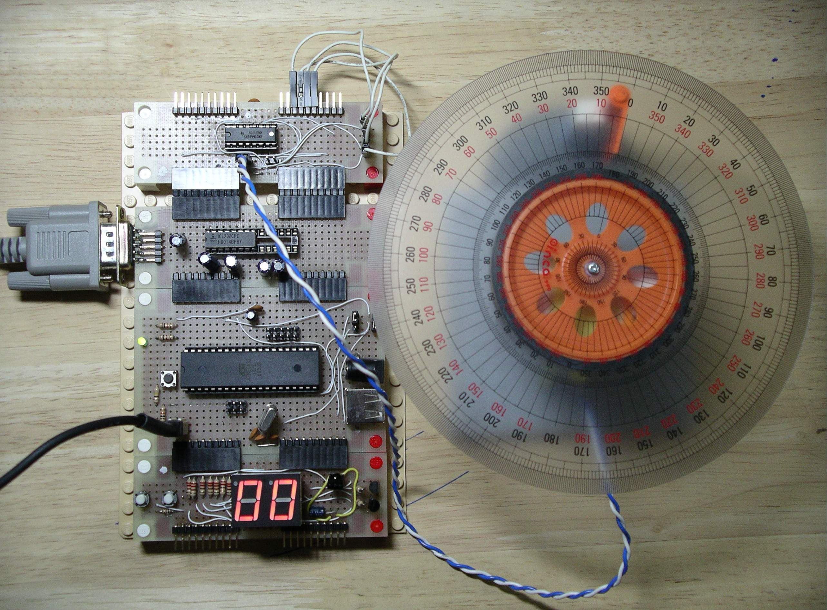

There are many types of motors in the markets. Servo motors are use for precision movement but still expensive. Toy DC motors are cheap but lack of feedback control for the movement. Stepping motor
Seem to be the right solutions for cost and movement control. But mostly they need high voltage for high torque and many control lines for one motor.
In this project, we will propose control toy motor using back emf approach. They are very cheap and a lot of models available in the market. With one H-bridge DC motor control and one microcontroller (ATMEGA32) we can control the speed, direction and angle for separate motor using text commands via serial port. Simple text command control makes it easy to interface with other module (Ex. PC, Other control board) we can use this module to replace servo motor in the non critical precision movement. Example in robot arm, we can detect when the motor stop without any contact switch. This solution will be ideal for robot which need angle movement and cheap enough for hobby.
From the experiments, we found that for no load the error is between +/- 3 Degree for moving 50 degree. However, the error increase when the angle become bigger than 50

Theory of operation
There are many methods to control motor. For example, using encoder, optical and hall effect. All of these methods need extra components to install on your project. Back emf is another approach that use the voltage generate from the motor to calculate speed and directions. The relations between back emf voltage and speed, angle and directions are
Speed proportional to speed
speed high --> Back emf high

Direction proportional to differential voltage
+V --> Forward
-V --> Backward
0 --> Stop
Angle relate to summation of back emf voltage

Because toy motors are Brush Dc motor and the power is very low. In this project, we will not use back emf to calculate speed, but simple setting pwm duty cycle for the speed. From experiments, it is very hard to adjust exact speed by using back emf because it's very small. For back emf sensing, we will sense in every pwm off period. This will make the error between setting value and measure value not more than 1 pulse. From experiments, error within 1 pulse is not makes any different.

System Diagram
In this project, the main components are Microcontroller and H-Bridge DC motor control SN754410 from TI. For testing purpose, we had added dual 7 segments display, IR receiver, two push button and max232 for communication with PC. We can show the system diagram as in the figure below
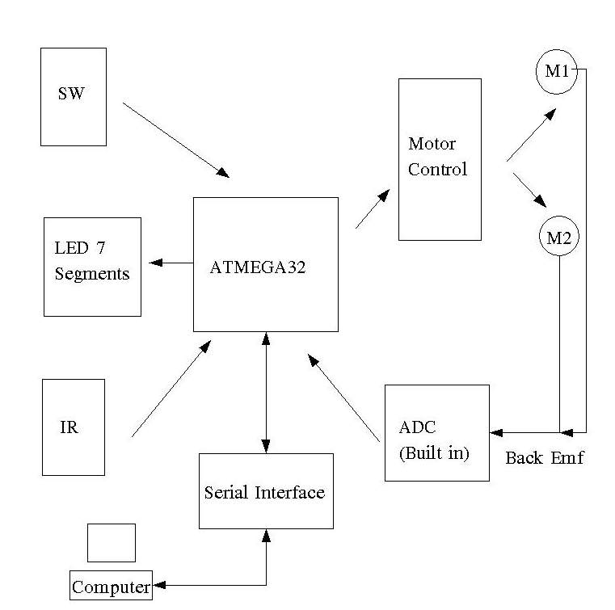
Figure 1 System block diagram ( AT3383_Block_Diagram.jpg)

ATMEG32 will generate PWM to control the speed of the motor. Two ports for each motor will be used for control signal send to H-bridge driver. During PWM off period. Back emf will be measured by ADC using differential mode. ATMEGA32 will sum the voltage to calculate the position. The text command for control speed, direction, and angle for each motor will be send via serial port. In this project, we just use hyper terminal to send text to control board. IR will be used to receive signal control for motor speed, run program which saved in EEPROM and control Move forward, Move backward, Turn left and Turn right for use in R/C model. LED 7 Segments will show the status of the motor whether it is forward, backward or stop. The push button switch will use to move forward, move backward each motor individually.

Hardware Basic
For prototype, we create each part in modules consist of CPU, I/O, Serial and Motor control. Each module will connected together via standard socket and standard pin configuration which we call E-block.
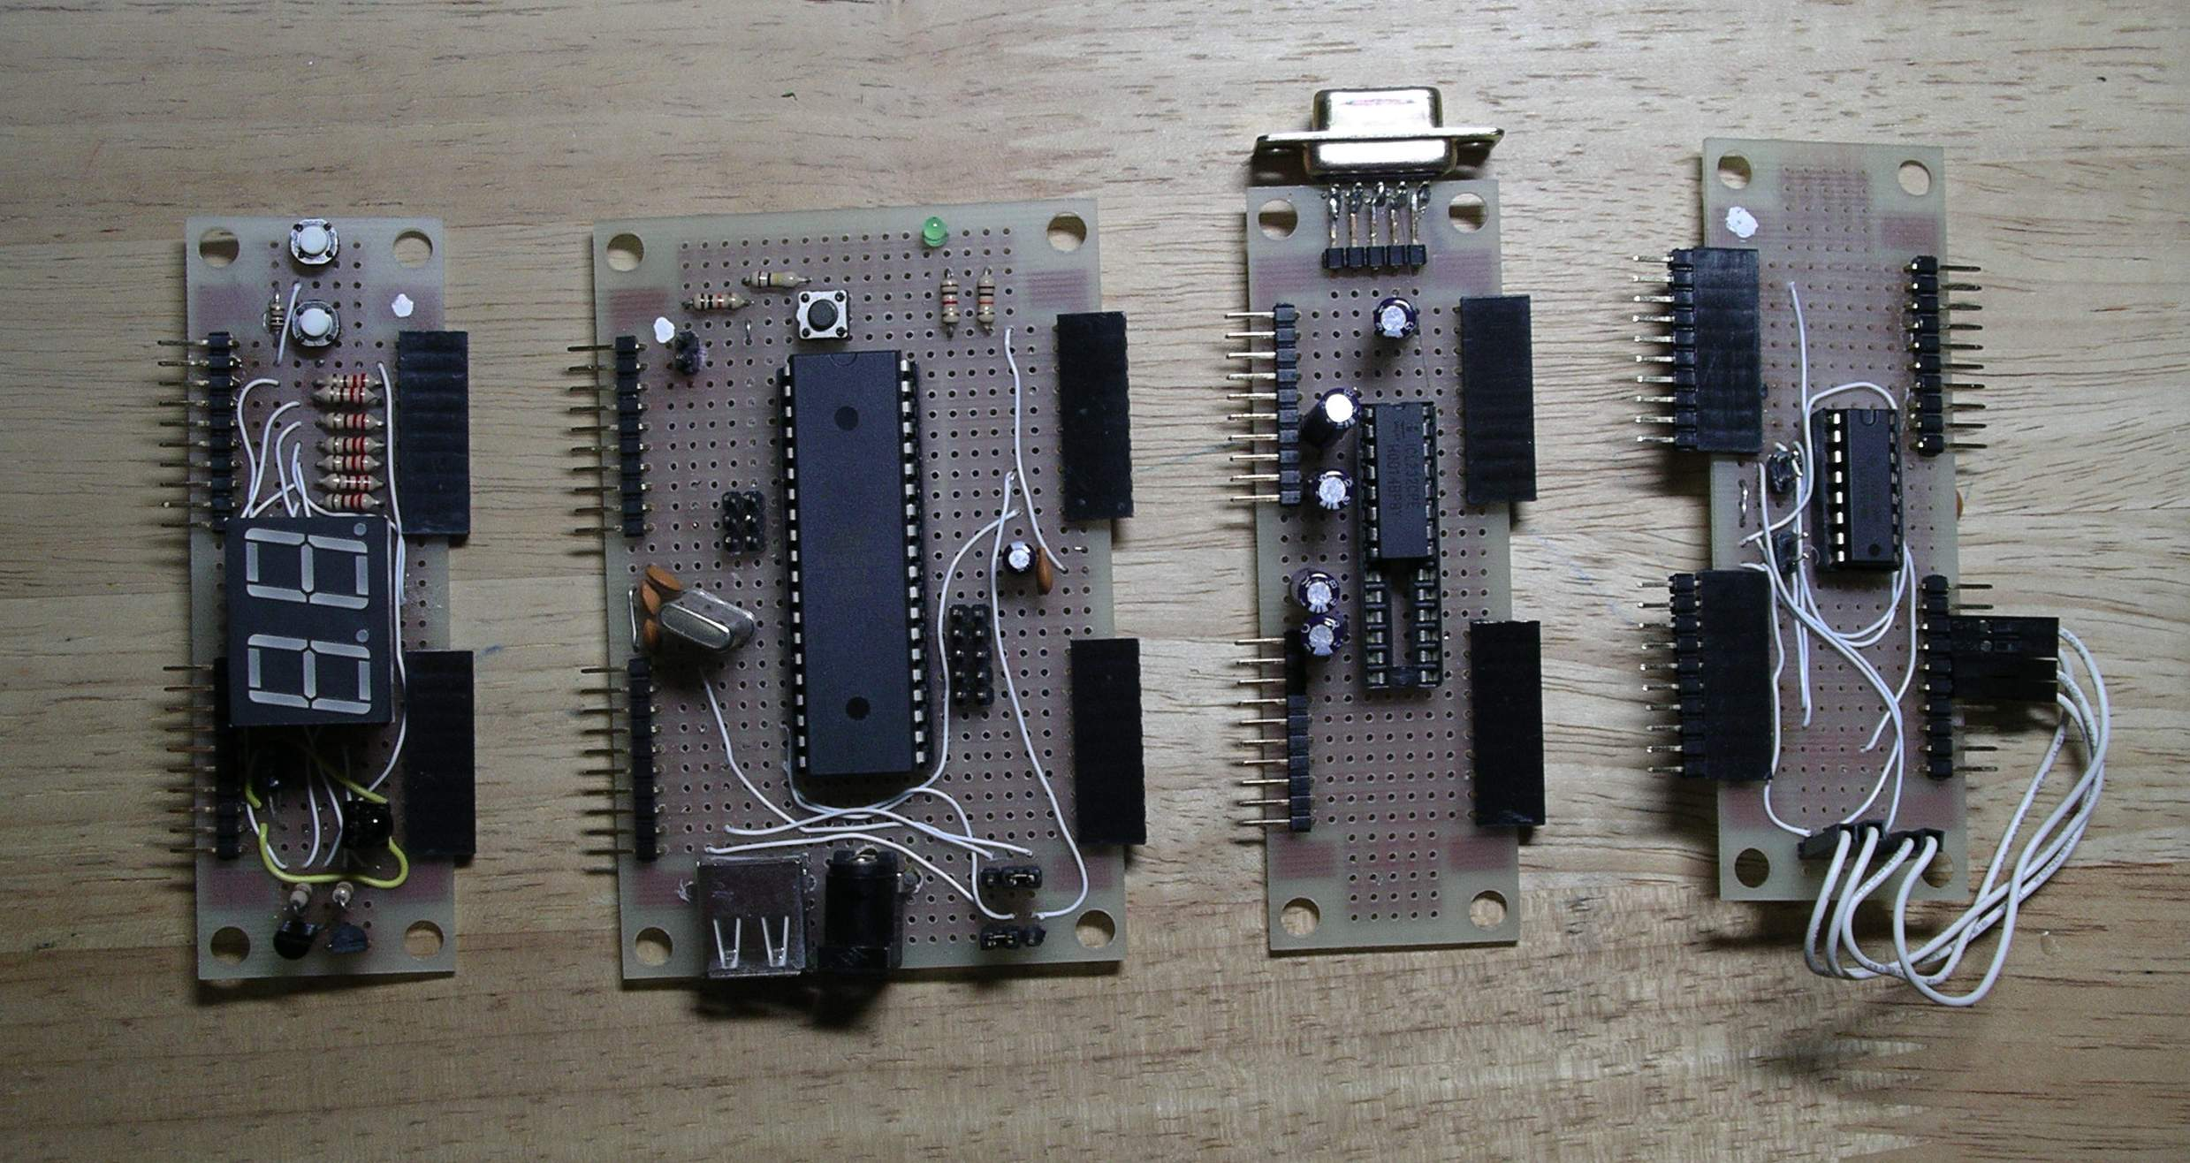

Figure 2 E-block connection (AT3383_E_block.jpg)

CPU board

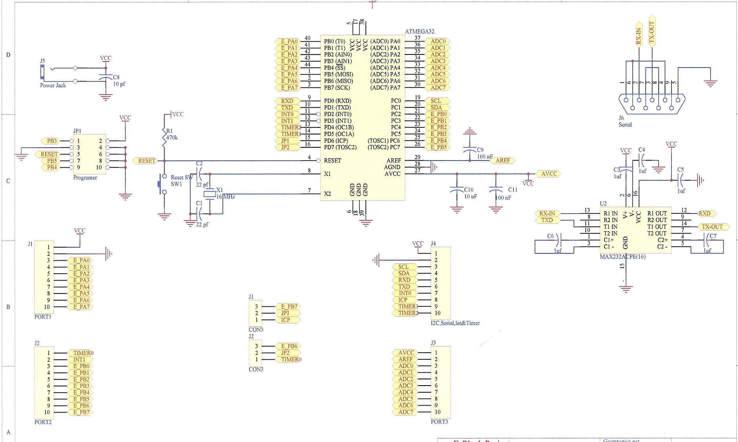

Figure 3 CPU board ( AT3383_CPU.jpg)

Input/Output board

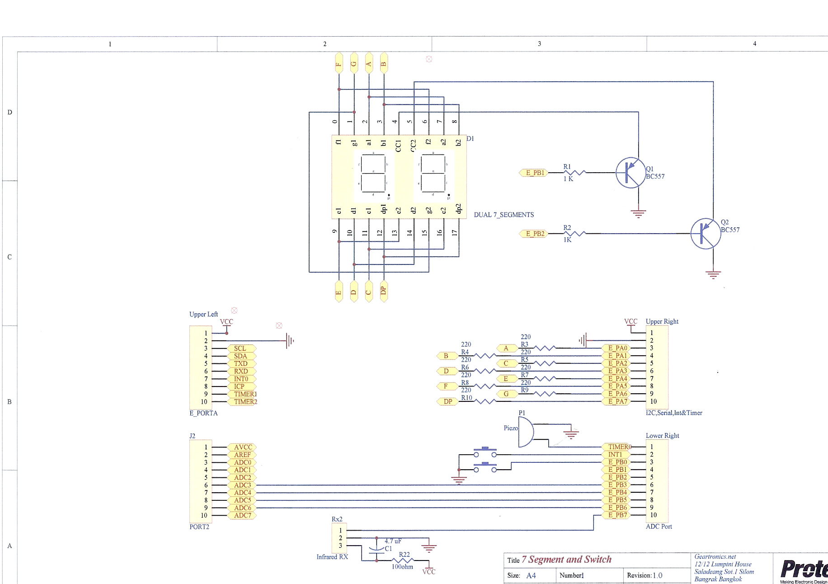
Figure 4 IO board ( AT3383_IO.jpg)

Serial interface
We are using max232 to convert signal between PC and microcontroller. This board is simple just one IC and some capactiors. See figure 3 for the diagram.

Motor control board
We use TI 754410 H-bridge driver control on motor control board. PWM is control by on/off enable12 and enable34 according to timer set.
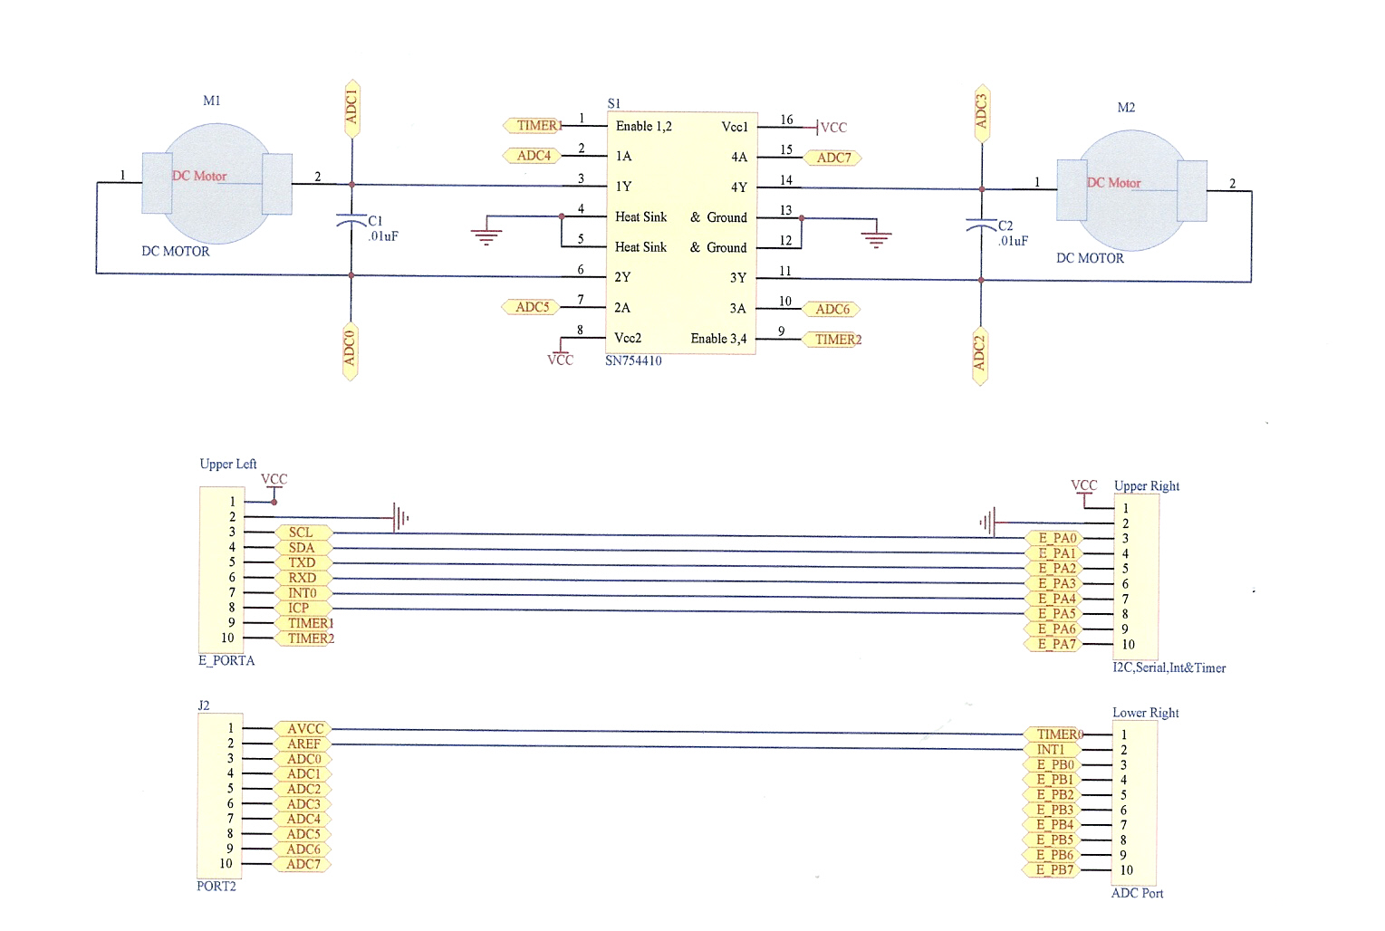

Figure 5 Motor Control board ( AT3383_MOTOR_CONTROL.jpg)

Software Development
We use winavr with avr-gcc (3.4.3) for this project. The software is written in module follow the hardware module which are Dual_7segments.c DC_motor.c, E_uart.c, adc.c. ir_tv.c text_decode.c for text command for interpret text command and backemf.c for the main program

Motor control
We use PWM method for control the speed of motor. PWM is generated by 8 bit timer0 timer2, because timer 1 is used for ICP in remote control. PWM’s frequency have effect to motor control resolution. If PWM’s frequency too high, motor will not move. If PWM’s frequency too low, motor will not move with load. From our experiments we set PWM’s frequency = 62.5 Khz. For duty cycle, the length of PWM should more than 50% to make motor move with load. We calculate duty cycle from OCR0 in timer0 and OCR2 in timer2.

For timer 0 PWM will on from 0- OCR0 and off from OCR0 – 0xFF
For timer 2 PWM will on from OCR2- 0 and off from 0- OCR2

Then we need to re-calculate OCR2 to make PWM both channel equal. The reason we need to shift PWM because we want to calculate back emf in different time slot.
The source code below show how to set PWM frequency and how to sense back emf in PWM off period.

void init_motor ()
{
// Initial for PWM Motor control for TIMER0 & 2

// TIMER0
TCCR0 |= _BV(WGM00) |_BV(WGM01) | _BV(CS02) ; // Clk/256 Pwm
OCR0 = 0x80;

// TIMER2
TCCR2 |= _BV(WGM20) |_BV(WGM21) | _BV(CS22) | _BV(CS21) ; // Clk/256 Pwm
OCR2 = 0x80;

// Enable Interrupt Watch out nest interrupt
TIMSK |= _BV(OCIE0) | _BV(TOIE0) | _BV(OCIE2) | _BV(TOIE2);
MOTOR_DIRECTION_DIR |= MOTORA_1 | MOTORA_2 | MOTORB_1 | MOTORB_2;
MOTOR_ENABLE12_DIR |= MOTOR_ENABLE12;
MOTOR_ENABLE34_DIR |= MOTOR_ENABLE34;
}

For timer 0 PWM will on from 0- OCR0 and off from OCR0 – 0xFF
For timer 2 PWM will on from OCR2- 0 and off from 0- OCR2
To get the stable back emf voltage,we will send back emf before PWN on as shown in the code below.

// Interrupt Vector table
// Couter timer 0 reach top
// ON Motor 0 - OCR0 ON OCR0 - 0xFF OFF
SIGNAL (SIG_OVERFLOW0)
{
calculate_backemf(0);
OCR0 = g_speed[0];
motor_control(1, g_mode[0]);
MOTOR_ENABLE12_CONTROL |= MOTOR_ENABLE12; // Enable Motor control

}

// Counter timer 0 reach OCR0 OFF MOTOR
SIGNAL (SIG_OUTPUT_COMPARE0)
{
MOTOR_ENABLE12_CONTROL &= ~(MOTOR_ENABLE12); // Disable Motor control Float motor
}

// TIMER2 will opposite with timer 0 to balance calculate backemf between timer0 and timer2
// Couter timer 2 reach top
// ON Motor 0 - OCR2 ON OCR2 - 0xFF FF
SIGNAL (SIG_OVERFLOW2)
{
MOTOR_ENABLE34_CONTROL &= ~(MOTOR_ENABLE34); // Disable Motor control Float motor
}

// Counter timer 2 reach OCR2 ON MOTOR
SIGNAL (SIG_OUTPUT_COMPARE2)
{
calculate_backemf(1);
OCR2 = 0xFF - g_speed[1]; // Because opposite with timer0
motor_control(2, g_mode[1]);
MOTOR_ENABLE34_CONTROL |= MOTOR_ENABLE34;
}

Back emf sensing

Back emf is measure during PWM off period. By floating motor power lines and sense back emf. The input will fed to differential amplifier built in ATMEGA32. The output will between 0 -512 for +V and -512-0 for -V. The negative will be in 2's complement, we need to convert it back to positive value. From this characteristics, we can known which direction motor is moving.

Angle calculation
Angle is calculate by summation of back emf voltage in each pwm off period. If speed motor is fast, the back emf will be bigger. As a result, the position will reach faster. If speed is slow the back emf will small but hard to get precision movement. We sum the voltage for every PWM because we would like to control the angle resolution as much as we can. From this experiments, one PWM with varying duty cycle will not make different much for the angle then we can ignore to adjust last few PWM’s duty cycle to get the closer voltage summation..
Source code below show how to measure back emf and get the voltage summation to calculate angle.

/* Calculate back emf and save in g_pos
*/
void calculate_backemf (uint8_t motor)
{
int16_t backemf=0;

// Read backemf Diff AMP
adc_init(1);
backemf = read_adc(g_adc_channel[motor]);

// Cut offset
if ((backemf > 0) && (backemf < MOTOR_OFFSET))
backemf =0;

// Negative convert to positive with 2 complement
if (g_mode[motor] == MOTOR_STOP)
{
if (backemf & 0x200)
{
backemf = (~(backemf) & (0x03FF))+1;
}
}
if (g_mode[motor] == MOTOR_FORWARD) // If motor forward ignore the positive value
{
if (backemf & 0x200)
{
backemf = (~(backemf) & (0x03FF))+1;
}
else
backemf = 0;
}
if (g_mode[motor] == MOTOR_BACKWARD) // If motor backward ignore the negative value
{
if (backemf & 0x200)
{
backemf =0;
}
}
g_pos[motor] += backemf;
//Compare voltage
if (((g_angle[motor] > 1)) && ( g_mode[motor] != MOTOR_STOP))
{
//Compare voltage sum
if ( g_pos[motor] >= (g_angle[motor])) // Check for position
{
g_mode[motor] = MOTOR_STOP;
uart_puts ("Voltage SUM");
debug_lvalue(g_pos[motor],10);
g_pos[motor] =0;
g_status[motor] = 0; // Clear status proceed with next command
}
}
}

Command line interface

To make it simple and easy to remember, we use simple understandable word to control speed and angle. The command format will be
Command = Arguments ( use “” to enclose for text)
Command
motor = Motor number ( number) to choose
speed = Motor speed (0-8)
angle = 1 Continuous move
angle = x Move forward X degree
angle = -x Move backward X degree
program = 1 put command into buffer
= 0 Cancel put command into buffer
save = 1 Put command in buffer into eeprom
run = 1 run program in EEPROM
The text_decode routine in text_decode.c will detect the command and argument and send the command number and argument pointer back to the caller. The commnand can be added easily by expand the text_cmd table in text_decode.c. Don't forget to update CMD_NUM equal to number of command +1.

Remote driver
In the project the format of Sony remote control will be used. Because it’s simple and just 12 - 15 bits length. Sony use Pulse width technique to represent 1 and 0

Remote button that use in this project are
Button | Function
1-9 | Speed Control
0 | Stop
AV/TV | Run program which save in EEPROM
Ch+ | Move forward (2 Motor Forward)
Ch- | Move backward (2 Motor Backward)
Vol+ | Turn Left ( 1 Motor Forward 1 Backward)
Vol - | Turn right( 1 Motor backward 1 Forward)

7 segments and SW driver
For simple testing, the push SW and 7 segments will put in main while loop to check whether SW1 or SW2 is pressed. These switches will use to control individual motor in order from forward, backward and stop. 7 Segments will display mode of motor at the current status.

Application
With simple and easy to use simple back emf control module. We can use this to replace servo motor where the precision is not so critical. For example, spin the robot head left and right in different angle. Robot arm for grasp something. Control speed and distance for R/C model.
Because few components are needed, the module can embedded in any DC motor control project to make it possible for angle movement and continuous movement.

Future Enhancement
In the future we can enhance more features in back emf control module. Here is the list that we plan to do in the future.
- Downgrade to ATMEGA8 to make it smaller and cheaper but extra circuit will need for differential input
- Increase to 4 motor control
- Add Xon/Xoff to sync the communication between module and controller
- Add response command to report motor stop status
- Algorithm for compensate friction, motor load

